

Semester Two Examination, 2024
Question/Answer booklet

MATHEMATICS
METHODS
UNITS 3&4

SOLUTIONS
Section One:
Calculator-free
WA student number: In figures

In words

Your name

Number of additional
answer booklets used
(if applicable):

Time allowed for this section
Reading time before commencing work: five minutes
Working time: fifty minutes

Materials required/recommended for this section
To be provided by the supervisor
This Question/Answer booklet
Formula sheet

To be provided by the candidate
Standard items: pens (blue/black preferred), pencils (including coloured), sharpener,
correction fluid/tape, eraser, ruler, highlighters

Special items: nil

Important note to candidates
No other items may be taken into the examination room. It is your responsibility to ensure that you do not have any unauthorised material. If you have any unauthorised material with you, hand it to the supervisor before reading any further.

Structure of this paper

Section | Number of  questions  available | Number of  questions to  be answered | Working  time  (minutes) | Marks  available | Percentage  of  examination
Section One:  Calculator-free | 7 | 7 | 50 | 52 | 35
Section Two:  Calculator-assumed | 10 | 10 | 100 | 97 | 65
 |  |  |  | Total | 100

Instructions to candidates

1. The rules for the conduct of examinations are detailed in the school handbook. Sitting this examination implies that you agree to abide by these rules.

2. Write your answers in this Question/Answer booklet preferably using a blue/black pen.
Do not use erasable or gel pens.

3. You must be careful to confine your answers to the specific question asked and to follow any instructions that are specific to a particular question.

4. Show all your working clearly. Your working should be in sufficient detail to allow your answers to be checked readily and for marks to be awarded for reasoning. Incorrect answers given without supporting reasoning cannot be allocated any marks. For any question or part question worth more than two marks, valid working or justification is required to receive full marks. If you repeat any question, ensure that you cancel the answer you do not wish to have marked.

5. It is recommended that you do not use pencil, except in diagrams.

6. Supplementary pages for planning/continuing your answers to questions are provided at the end of this Question/Answer booklet. If you use these pages to continue an answer, indicate at the original answer where the answer is continued, i.e. give the page number.

7. The Formula sheet is not to be handed in with your Question/Answer booklet.
Section One: Calculator-free 35% (52 Marks)
This section has seven questions. Answer all questions. Write your answers in the spaces provided.

Working time: 50 minutes.

Question 1 (7 marks)
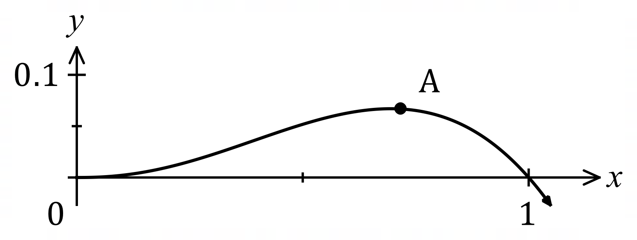
The graph of $y=f(x)$ is shown,
where $f\left(x\right)=x^{2}\left(\sqrt{x}-x\right)$.

(a) Determine the $x$-coordinate of the stationary point marked $A$ in the graph. (4 marks)

Solution
Derivative:
$$f^{'}\left(x\right)=2x\left(\sqrt{x}-x\right)+x^{2}\left(\frac{1}{2\sqrt{x}}-1\right) \text{or} f\left(x\right)=x^{2.5}-x^{3}→f^{'}\left(x\right)=2.5x^{1.5}-3x^{2}$$
Stationary point:
$$f^{'}\left(x\right)=0 \\ 2.5x^{1.5}-3x^{2}=0 \\ x^{2}\left(\frac{2.5}{\sqrt{x}}-3\right)=0 \\ \sqrt{x}=\frac{2.5}{3}=\frac{5}{6}⇒x=\frac{25}{36}$$

Specific behaviours
indicates use of product rule or expands $f(x)$
ü correct derivative
simplifies and factors $f^{'}\left(x\right)=0$
ü correct value of $x$

(b) Determine the area between the curve and the $x$-axis between $x=0$ and $x=1$.
(3 marks)
Solution
$$A=\int_{0}^{1}{\left(x^{2.5}-x^{3}\right)}dx \\ ={\left[\frac{x^{3.5}}{3.5}-\frac{x^{4}}{4}\right]}_{0}^{1} \\ =\frac{1}{3.5}-\frac{1}{4}=\frac{2}{7}-\frac{1}{4}=\frac{1}{28} \text{sq units}$$

Specific behaviours
writes correct integral
ü correct antiderivative
ü correct area

Question 2 (8 marks)
Determine the following:

(a) $\int{\underset{ }{6\cos\left(2x+3\right)}}dx$. (2 marks)
Solution
$$\int{\underset{ }{6\cos\left(2x+3\right)}}dx=3\sin{(2x+3)}+c$$

Specific behaviours
correct antiderivative
ü constant of integration

(b) $\int_{0}^{3}{\begin{matrix}d \\ \overline{dx}\end{matrix}\left(\sin\left(\begin{matrix}πx \\ \overline{ 4 }\end{matrix}\right)\right) }dx$. (2 marks)
Solution
$$\int_{0}^{3}{\begin{matrix}d \\ \overline{dx}\end{matrix}\left(\sin\left(\begin{matrix}πx \\ \overline{ 4 }\end{matrix}\right)\right) }dx={\left[\sin\left(\begin{matrix}πx \\ \overline{ 4 }\end{matrix}\right)\right]}_{0}^{3} \\ =\sin\left(\begin{matrix}3π \\ \overline{ 4 }\end{matrix}\right)-\sin\left(0\right) \\ ={\sqrt{2}}/2$$

Specific behaviours
eliminates integral
ü correct value

(c) $\int_{1}^{4}{\underset{ }{\sqrt{3x-3}}}dx$. (2 marks)
Solution
$$\int_{1}^{4}{\underset{ }{\sqrt{3x-3}}}dx=\int_{1}^{4}{{\left(3x-3\right)}^{\frac{1}{2}}}dx \\ ={\left[\frac{1}{3}×\frac{2}{3}×{\left(3x-3\right)}^{\frac{3}{2}}\right]}_{1}^{4} \\ =\frac{2}{9}{\left(9\right)}^{\frac{3}{2}}-0 \\ =6$$

Specific behaviours
correct antiderivative
ü correct value

(d) $\begin{matrix}d \\ \overline{dy}\end{matrix}\int_{y}^{1}{(2-\underset{ }{e^{π-4x})}}dx$. (2 marks)
Solution
$$\begin{matrix}d \\ \overline{dy}\end{matrix}\int_{y}^{1}{(2-\underset{ }{e^{π-4x})}}dx=\begin{matrix}d \\ \overline{dy}\end{matrix}\int_{-1}^{y}{\underset{ }{{(e}^{π-4x}-2)}}dx=e^{π-4y}-2$$

Specific behaviours
ü indicates use of fundamental theorem
ü correct expression

Question 3 (8 marks)
(a) Express using natural logarithms the $x$-coordinate of the point where the curve $y=5^{-x}$ intersects with the curve $y=3^{1-2x}$. (3 marks)
Solution
$$3^{1-2x}=5^{-x} \\ \ln\left(3^{1-2x}\right)=\ln\left(5^{-x}\right) \\ \left(1-2x\right)\ln{3}=-x\ln{5} \\ \ln{3}-2x\ln{3}+x\ln{5}=0 \\ x\left(\ln{5}-2\ln{3}\right)=-\ln{3} \\ x=\frac{\ln{3}}{2\ln{3}-\ln{5}}$$

Specific behaviours
uses log laws to obtain linear equation in $x$
ü collects like terms
ü correct $x$-coordinate

(b) Given that $f(x)$ has domain $x>-5$, has derivative $f^{'}\left(x\right)=\begin{matrix}1 \\ \overline{x+5}\end{matrix}$, and the curve $y=f(x)$ passes through the point $(-4, 7)$, determine an expression for $f(x)$. (2 marks)
Solution
$$f\left(x\right)=\int{\frac{1}{x+5}}dx \\ =\ln{(x+5)}+c$$
Using $\left(-4, 7\right)$:
$$7=\ln{(1)}+c⇒c=7$$

$$f\left(x\right)=\ln{(x+5)}+7$$

Specific behaviours
correct antiderivative
ü correct $f(x)$

(c) Solve the equation $\ln{(x+3)}-2=\ln{x}$. (3 marks)
Solution
$$\ln\left(x+3\right)=\ln{x}+2 \\ \ln\left(x+3\right)=\ln{x}+\ln{e^{2}} \\ \ln\left(x+3\right)=\ln{xe^{2}} \\ x+3=xe^{2} \\ xe^{2}-1=3 \\ x\left(e^{2}-1\right)=3 \\ x=\frac{3}{e^{2}-1}$$

Specific behaviours
writes $2$ as $\ln{e^{2}}$
ü correctly obtains equation of form $\ln\left(f\right)=\ln\left(g\right)$
ü correct solution

Question 4 (7 marks)
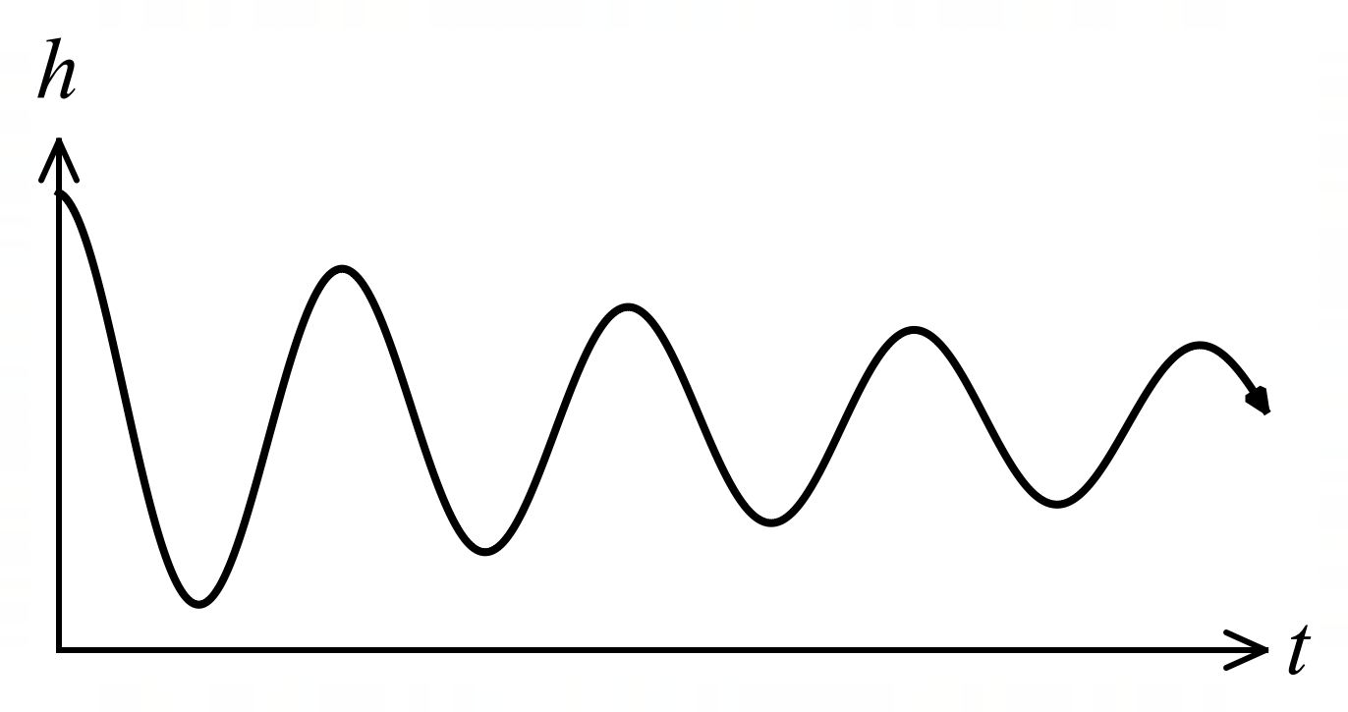
The graph shows the height $h$ cm of
a small mass suspended by a spring
above a bench top $t$ seconds after it
was released, where
$$h=3+\frac{3\cos\left(4πt\right)}{t+1}.$$

(a) Calculate the height of the mass when $t=1$. (1 mark)
Solution
$$h\left(1\right)=3+\frac{3\cos\left(4π\right)}{2}=3+\frac{3}{2}=4.5 \text{cm}$$

Specific behaviours
correct height

(b) Determine the rate of change of height of the mass when $t=1$. (3 marks)
Solution
$$\frac{dh}{dt}=\frac{-12π\sin\left(4πt\right)\left(t+1\right)-3\cos\left(4πt\right)}{{\left(t+1\right)}^{2}}$$

When $t=1$
$$\frac{dh}{dt}=\frac{-12π\sin\left(4π\right)\left(2\right)-3\cos\left(4π\right)}{2^{2}} \\ =\frac{0-3}{4}=-\frac{3}{4} \text{cm/s}$$

Specific behaviours
evidence of use of quotient rule
ü correct derivative
ü correct rate of change

(c) Use the increments formula to estimate the height of the mass when $t=1.1$. (3 marks)
Solution
$$δh≈δt×\frac{dh}{dt} \\ ≈(1.1-1)×-\frac{3}{4} \\ ≈-0.075$$

Height will be $h\left(1\right)-0.075=4.5-0.075=4.425$ cm.

Specific behaviours
indicates correct use of increments formula
ü evaluates change in height
ü correct height

Question 5 (8 marks)
A curve passes through the point $(0, -2)$ and is such that $\begin{matrix}dy \\ \overline{\overset{ }{dx}}\end{matrix}=e^{3x}-3e^{-2x}$.

(a) Determine the equation of the curve. (3 marks)
Solution
$$f\left(x\right)=\int{e^{3x}-3e^{-2x}}dx \\ =\frac{e^{3x}}{3}+\frac{3e^{-2x}}{2}+c \\ f\left(0\right)⇒\frac{1}{3}+\frac{3}{2}+c=-2, c=\frac{-12-2-9}{6}=-\frac{23}{6} \\ f(x)=\frac{e^{3x}}{3}+\frac{3e^{-2x}}{2}-\frac{23}{6}$$

Specific behaviours
correctly antidifferentiates
ü forms equation using constant of integration $c$
ü correct equation of curve

(b) Show that the curve is always concave up. (2 marks)
Solution
$$f^{''}\left(x\right)=3e^{3x}+6e^{-2x}$$$f^{''}\left(x\right)>0$ since $e^{k}>0$.

Since the second derivative is always positive, the curve is always concave up.

Specific behaviours
ü obtains second derivative
ü explains concave up using sign of $f''(x)$

(c) Determine the $x$-coordinate and nature of the stationary point of the curve. (3 marks)
Solution
$$f^{'}\left(x\right)=0 \\ e^{3x}-3e^{-2x}=0 \\ e^{3x}=3e^{-2x} \\ e^{5x}=3 \\ x=\frac{1}{5}\ln{3}$$
Since curve is always concave up, there is a minimum at $x=\begin{matrix}1 \\ \overline{5}\end{matrix}\ln{3}$.

Specific behaviours
equates $f^{'}\left(x\right)=0$ and simplifies
ü obtains $x$-coordinate of stationary point
ü states nature of stationary point

Question 6 (7 marks)
The excess length $X$ m of a roll of cable is a continuous random variable whose probability density function is shown below.
$$f\left(x\right)=\left\{ \begin{matrix}\frac{k}{2x+1} & 0≤x≤3 \\ 0 & \text{otherwise.}\end{matrix}\right.$$

(a) Show that the constant $k=\begin{matrix}2 \\ \overline{\ln{7}}\end{matrix}$. (4 marks)
Solution
$$\int_{0}^{3}{\frac{k}{2x+1}}dx=1 \\ {\left[\frac{k}{2}\ln\left(2x+1\right)\right]}_{0}^{3}=1 \\ \frac{k}{2}\ln\left(2\left(3\right)+1\right)-\frac{k}{2}\ln\left(2\left(0\right)+1\right)=1 \\ \frac{k}{2}\ln\left(7\right)-\frac{k}{2}\ln\left(1\right)=1 \\ \frac{k}{2}\ln\left(7\right)-0=1 \\ k=\frac{2}{\ln{7}}$$

Specific behaviours
indicates that integral of $f$ between bounds equals $1$
ü determines correct antiderivative
ü correctly substitutes bounds
ü shows working to derive value of $k$

The cumulative distribution function of $X$ is shown below.

$$P\left(X≤x\right)=\left\{\begin{matrix}0 & x<0 \\ g(x) & 0≤x≤3 \\ 1 & x>3\end{matrix}\right.$$

(b) Determine an expression for $g(x)$. (2 marks)
Solution
$$g\left(x\right)=\int_{0}^{x}{\frac{k}{2t+1}}dt \\ =\frac{k}{2}\ln\left(2x+1\right) \\ =\frac{\ln\left(2x+1\right)}{\ln{7}}$$

Specific behaviours
indicates required integral
ü correct expression

(c) Determine the probability that the excess length is no more than $2.5$ m. (1 mark)
Solution
$$P\left(X≤1\right)=\frac{\ln{6}}{\ln{7}}$$

Specific behaviours
correct probability

Question 7 (7 marks)
(a) The function $f\left(x\right)={\left(\ln\left(\begin{matrix}x \\ \overline{2}\end{matrix}\right)\right)}^{2}+a\ln\left(\begin{matrix}x \\ \overline{2}\end{matrix}\right)+b$ has a local minimum at $\left(2e^{-4}, -5\right)$. Determine the value of the constant $a$ and the value of the constant $b$. (4 marks)
Solution
$$f^{'}\left(x\right)=\frac{2}{x}\ln\left(\begin{matrix}x \\ \overline{2}\end{matrix}\right)+\frac{a}{x}=\frac{1}{x}\left(2\ln\left(\frac{x}{2}\right)+a\right)$$

$$f^{'}\left(2e^{-4}\right)=0⇒2\ln\left(\frac{2e^{-4}}{2}\right)+a=0$$

$$2(-4)+a=0⇒a=8$$

$$\left(2e^{-4}, -5\right)⇒{\left(\ln\left(\frac{2e^{-4}}{2}\right)\right)}^{2}+8\ln\left(\frac{2e^{-4}}{2}\right)+b=-5$$
$${\left(-4\right)}^{2}+8\left(-4\right)+b=-5⇒b=11$$

$$a=8, b=11$$

Specific behaviours
correct $f'(x)$
ü forms equation for $a$
ü correct value of $a$
ü correct value of $b$

(b) Solve the simultaneous equations $\log_{6}{x}+\log_{6}{y}=2$ and $\log_{6}{x^{2}}-\log_{6}{y^{4}}=1$ for $x$
and $y$. (3 marks)
Alternative Solution
$$\log_{6}{x}+\log_{6}{y}=2 \\ \log_{6}{x^{2}}-\log_{6}{y^{4}}=1$$

$$xy=6^{2}⇒y=6^{2}x^{-1} \\ \frac{x^{2}}{y^{4}}=6 \\ x^{2}=6{\left(6^{2}x^{-1}\right)}^{4} \\ x^{6}=6^{9}⇒x=6^{\frac{3}{2}}=6\sqrt{6}$$

$$y=6^{2}{\left(6^{\frac{3}{2}}\right)}^{-1}=6^{\frac{1}{2}}=\sqrt{6}$$

$$x=6\sqrt{6}, y=\sqrt{6}$$

Specific behaviours
shows correct use of log laws
ü correct value of $x$
ü correct value of $y$

Solution
$$\log_{6}{x}+\log_{6}{y}=2 \\ \log_{6}{x^{2}}-\log_{6}{y^{4}}=1$$

$$2\log_{6}{x}+2\log_{6}{y}=4 \\ -2\log_{6}{x}+4\log_{6}{y}=-1 \\ 6\log_{6}{y}=3 \\ \log_{6}{y}=\frac{1}{2}⇒y=\sqrt{6}$$

$$\log_{6}{x}=2-\log_{6}{y}=2-\frac{1}{2}=\frac{3}{2} \\ x=6^{\frac{3}{2}}=6\sqrt{6}$$

$$x=6\sqrt{6}, y=\sqrt{6}$$

Specific behaviours
shows correct use of log laws
ü correct value of $x$
ü correct value of $y$

Supplementary page

Question number: _________

Supplementary page

Question number: _________

© 2024 WA Exam Papers. Leeming Senior High School has a non-exclusive licence to copy and communicate this document for non-commercial, educational use within the school. No other copying, communication or use is permitted without the express written permission of WA Exam Papers. SN056-245-3.

